**DBMS Project**

**Pharmacy-Management-System**

**Introduction:**

Pharmacy Management system is a database application that will cater the needs of storing, managing, querying and retrieving pharmacy data needs i.e. managing staff, customer, transaction, product and supplier records. The application is generated by a script and is further beautified manually through Alex app builder.

**Description:**

The scenario was opted because of the storage and management requirements of a pharmacy. If a manual storage system is considered, a pharmacy can be maintained through some file or .xlsx sheet but that wouldn’t be the ideal practice. Realizing this, a pharmacy which is a proper Entity made up of several components having their own attributes and operations later to be discussed in the schema, an attempt to make an almost fully-automated database application was brought into action. The application has automated the operation by adding rows or records manually through graphical user interface which is a utility itself, deleting or updating records, generate reports, view charts and performing calculations.

**Schema :**

The schema consists of 6 entities and one bridge table. These tables are as follows:

Staff – The staff table consists of the records of employees or simply staff in the pharmacy. The attributes include Staff ID, which is serving as a Primary key, name, salary, commission, hire date, and their job.

Customer – The customer table consists of records of customers with attributes like customer ID (PK), name and phone number.

Supplier – Supplier contains records of supplier supplying products to pharmacy. The attributes include Supplier ID, Company Name, supplier name, address and phone number.

Product – Product table contains all the products the pharmacy sells or simply has as am inventory. It includes Product ID (PK), Product Name, Unit Price, Quantity, Supplier ID (FK) and Category ID (FK).

Category – The category table contains the records of the categories the products belong to. Attributes are category ID (PK), category name and the description of category.

Transaction – The transaction tables include records of the transactions made by customers. It’s attributes are Transaction ID (PK), Customer ID (FK), Staff ID (FK) and transaction Date.

Transaction Details – This table serves as a bridge table between transaction and the products on which transactions are made. It’s attributes includes Transaction ID (FK), Product ID (FK), Unit Price, Quantity and Discount.

**Entity Relationship Diagram:**

The below diagram depicts the entities (tables) and their relations. The diagram is designed using [Draw.io](https://app.diagrams.net/) , which is an online utility to design diagrams.

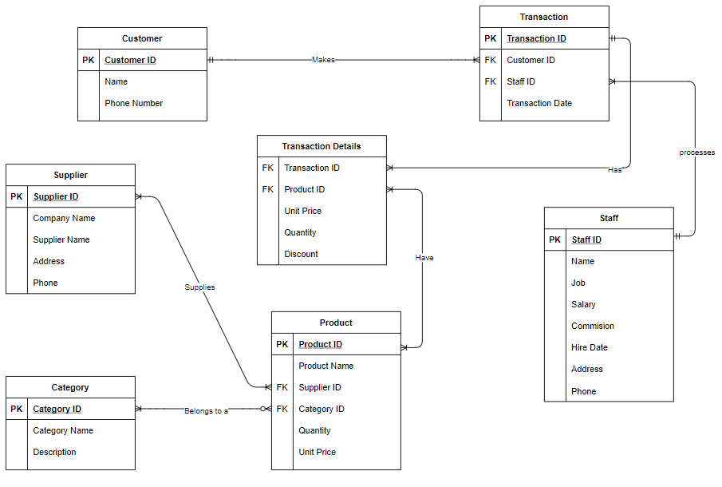

**Functional Dependencies:**

Following are the functional dependencies of attributes in each table:

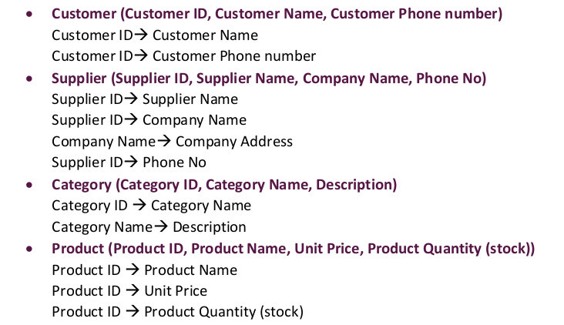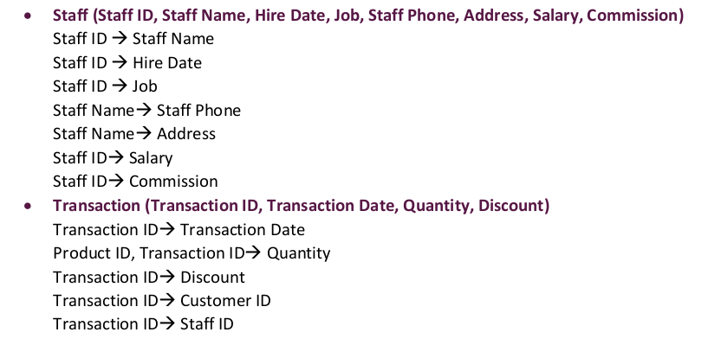

**Data Flow Diagram:**

The below diagram depicts how the data will flow throughout the database and which entity is doing what operation. It is to be noted that it is a level 0 DFD or simply a context diagram which would describe or give the overview of while application being modeled or analyzed.

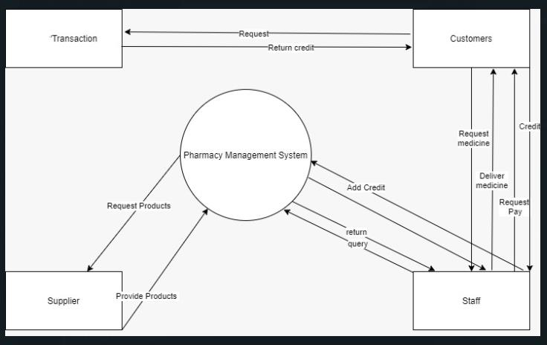

Sql: -

|  |
| --- |
| CREATE TABLE Staff |
|  | ( |
|  | StaffID NUMBER NOT NULL, |
|  | Name VARCHAR2(20) NOT NULL, |
|  | Job VARCHAR2(30), |
|  | Salary NUMBER(7, 2), |
|  | Commission NUMBER(7, 2), |
|  | HireDate DATE, |
|  | Address VARCHAR2(60), |
|  | Phone VARCHAR2(24), |
|  |  |
|  | CONSTRAINT PK_Staff PRIMARY KEY (StaffID) |
|  |  |
|  | ) |
|  | / |
|  |  |
|  | CREATE TABLE Category |
|  | ( |
|  | CategoryID NUMBER NOT NULL, |
|  | CategoryName VARCHAR2(30) NOT NULL, |
|  | Description VARCHAR2(300), |
|  |  |
|  | CONSTRAINT PK_Category PRIMARY KEY (CategoryID)) |
|  |  |
|  | / |
|  |  |
|  |  |
|  | CREATE TABLE Customer |
|  | ( |
|  | CustomerID NUMBER NOT NULL, |
|  | CustomerName VARCHAR2(30), |
|  | Phone VARCHAR2(24), |
|  |  |
|  | CONSTRAINT PK_Customer PRIMARY KEY (CustomerID) |
|  | ) |
|  | / |
|  |  |
|  |  |
|  | CREATE TABLE Supplier |
|  | ( |
|  | SupplierID NUMBER NOT NULL, |
|  | CompanyName VARCHAR2(40) NOT NULL, |
|  | SupplierName VARCHAR2(30), |
|  | Address VARCHAR2(60), |
|  | Phone VARCHAR2(24), |
|  |  |
|  | CONSTRAINT PK_Supplier |
|  | PRIMARY KEY (SupplierID) |
|  | ) |
|  | / |
|  |  |
|  |  |
|  | CREATE TABLE Product |
|  | ( |
|  | ProductID NUMBER NOT NULL, |
|  | ProductName VARCHAR2(40) NOT NULL, |
|  | SupplierID NUMBER, |
|  | CategoryID NUMBER, |
|  | Quantity VARCHAR2(20), |
|  | UnitPrice NUMBER, |
|  |  |
|  |  |
|  | CONSTRAINT PK_Product |
|  | PRIMARY KEY (ProductID), |
|  | CONSTRAINT CHK_Product_Price CHECK ((UnitPrice >= 0)), |
|  | CONSTRAINT FK_Product_Category FOREIGN KEY (CategoryID) REFERENCES Category(CategoryID), |
|  | CONSTRAINT FK_Product_Supplier FOREIGN KEY (SupplierID) REFERENCES Supplier(SupplierID) |
|  | ) |
|  | / |
|  |  |
|  |  |
|  | CREATE TABLE Transaction |
|  | ( |
|  | TransactionID NUMBER NOT NULL, |
|  | CustomerID NUMBER, |
|  | StaffID NUMBER, |
|  | TransactionDate DATE, |
|  |  |
|  |  |
|  | CONSTRAINT PK_Transaction |
|  | PRIMARY KEY (TransactionID), |
|  | CONSTRAINT FK_Transaction_Customer FOREIGN KEY (CustomerID) REFERENCES Customer(CustomerID), |
|  | CONSTRAINT FK_Transaction_Staff FOREIGN KEY (StaffID) REFERENCES Staff(StaffID) |
|  | ) |
|  | / |
|  |  |
|  |  |
|  |  |
|  | CREATE TABLE TransactionDetails |
|  | ( |
|  | TransactionID NUMBER NOT NULL, |
|  | ProductID NUMBER NOT NULL, |
|  | UnitPrice NUMBER NOT NULL, |
|  | Quantity NUMBER NOT NULL, |
|  | Discount NUMBER NOT NULL, |
|  |  |
|  | CONSTRAINT PK_Transaction_Details |
|  | PRIMARY KEY (TransactionID, ProductID), |
|  | CONSTRAINT CHK_Discount CHECK ((Discount >= 0 and Discount <= 1)), |
|  | CONSTRAINT CHK_Quantity CHECK ((Quantity > 0)), |
|  | CONSTRAINT CHK_UnitPrice CHECK ((UnitPrice >= 0)), |
|  | CONSTRAINT FK_TransactionDetails_Transaction FOREIGN KEY (TransactionID) REFERENCES Transaction(TransactionID), |
|  | CONSTRAINT FK_TransactionDetails_Product FOREIGN KEY (ProductID) REFERENCES Product(ProductID) |
|  | ) |
|  | / |
|  |  |
|  |  |
|  |  |
|  | begin |
|  | INSERT INTO Customer(CustomerID, CustomerName, Phone) VALUES (001, 'Akram','03452004321'); |
|  | INSERT INTO Customer(CustomerID, CustomerName, Phone) VALUES (002, 'Afzal','03122004321'); |
|  | INSERT INTO Customer(CustomerID, CustomerName, Phone) VALUES (003, 'Asif','03352004321'); |
|  | INSERT INTO Customer(CustomerID, CustomerName, Phone) VALUES (004, 'Areeb','03332004321'); |
|  | INSERT INTO Customer(CustomerID, CustomerName, Phone) VALUES (005, 'Ahsan','03234304321'); |
|  | INSERT INTO Customer(CustomerID, CustomerName, Phone) VALUES (006, 'Basit','03234204321'); |
|  | INSERT INTO Customer(CustomerID, CustomerName, Phone) VALUES (007, 'Brian','0338574321'); |
|  | INSERT INTO Customer(CustomerID, CustomerName, Phone) VALUES (008, 'Catherine','0354554421'); |
|  | INSERT INTO Customer(CustomerID, CustomerName, Phone) VALUES (009, 'Carla','03335423321'); |
|  | commit; |
|  | end; |
|  | / |
|  |  |
|  |  |
|  | begin |
|  | INSERT INTO Category(CategoryID, CategoryName, Description) VALUES (001, 'Food and beverages', 'Soft drinks, coffees,chips, teas, nimcos'); |
|  | INSERT INTO Category(CategoryID, CategoryName, Description) VALUES (002, 'Skin care', 'Creams, Tubes,Ointments,Gels,Oil'); |
|  | INSERT INTO Category(CategoryID, CategoryName, Description) VALUES (003, 'Feminine Products', 'Sanitary Pads, OTC Products,Sanitary Napkins, Hair Removing Creams'); |
|  | INSERT INTO Category(CategoryID, CategoryName, Description) VALUES (004, 'Medicine', 'Tablets, Syrups,Injections, Drips, Ointments'); |
|  | INSERT INTO Category(CategoryID, CategoryName, Description) VALUES (005, 'Baby & Mother Care', 'Feeders, Pampers,Nipples, Baby Eatables, Napkins'); |
|  | commit; |
|  | end; |
|  | / |
|  |  |
|  |  |
|  | begin |
|  | INSERT INTO Product(ProductID, ProductName, SupplierID, CategoryID, Quantity, UnitPrice) VALUES (001, 'Johson Baby Lotion', 1, 1, 100, 180); |
|  | INSERT INTO Product(ProductID, ProductName, SupplierID, CategoryID, Quantity, UnitPrice) VALUES (002, 'Baby Diaper', 1, 2, 100, 50); |
|  | INSERT INTO Product(ProductID, ProductName, SupplierID, CategoryID, Quantity, UnitPrice) VALUES (003, 'Chips', 2, 4, 100, 180); |
|  | INSERT INTO Product(ProductID, ProductName, SupplierID, CategoryID, Quantity, UnitPrice) VALUES (004, 'Ascard', 1, 4, 100, 180); |
|  | INSERT INTO Product(ProductID, ProductName, SupplierID, CategoryID, Quantity, UnitPrice) VALUES (005, 'Humilin 70/30', 1, 4, 100, 180); |
|  | INSERT INTO Product(ProductID, ProductName, SupplierID, CategoryID, Quantity, UnitPrice) VALUES (006, 'Monteka', 1, 4, 100, 180); |
|  | commit; |
|  | end; |
|  | / |
|  |  |
|  |  |
|  | begin |
|  | INSERT INTO Staff(StaffID, Name, Job, Salary, Commission, Hiredate, Address, Phone) VALUES (001,'Mansoor Khan','Pharmacy technician',50000,1000,'12/10/2000','Street No XYZ, Block 93, Gulshan, Karachi', 0324789788); |
|  | INSERT INTO Staff(StaffID, Name, Job, Salary, Commission, Hiredate, Address, Phone) VALUES (002,'Luiz','Pharmacy assistant.',35000,150,'6/6/1999','House No PQR, Block 3, Sacramento, Karachi', 0321445588); |
|  | INSERT INTO Staff(StaffID, Name, Job, Salary, Hiredate, Address, Phone) VALUES (003,'Pique','Pharmacy clerk',25000,'2/3/2010','Street No ABC, Block 35, DHA, Karachi', 0300789788); |
|  | INSERT INTO Staff(StaffID, Name, Job, Salary, Commission, Hiredate, Address, Phone) VALUES (004,'Xavi','Pharmacy technician',50000,100,'3/4/2009','House No LMN, Block 90, KDA, Karachi', 0334089788); |
|  | INSERT INTO Staff(StaffID, Name, Job, Salary, Commission, Hiredate, Address, Phone) VALUES (005,'Iniesta','Pharmacy technician',200,1000,'6/25/2000','Street No WXY, Block 80, PIB, Karachi', 03747897188); |
|  | INSERT INTO Staff(StaffID, Name, Job, Salary, Commission, Hiredate, Address, Phone) VALUES (006,'Bale','Pharmacy assistant',40000,300,'12/31/2000','Street No KLM, Block 93, FB Area, Karachi', 0350897288); |
|  | INSERT INTO Staff(StaffID, Name, Job, Salary, Commission, Hiredate, Address, Phone) VALUES (007,'Lionel Messi','Pharmacist',12500,500,'2/28/2000','House No CDE, Block 93, Korangi 2, Karachi', 03217849788); |
|  | commit; |
|  | end; |
|  | / |
|  |  |
|  | begin |
|  | INSERT INTO Supplier(SUPPLIERID, COMPANYNAME, SUPPLIERNAME, ADDRESS, PHONE) VALUES (001,'Unity Foods Ltd','Nasir Khan Jan','Street No XYZ, Block 93, Gulshan, Karachi',03123325344); |
|  | INSERT INTO Supplier(SUPPLIERID, COMPANYNAME, SUPPLIERNAME, ADDRESS, PHONE) VALUES (002,'Hilton Pharma','Akram Bloch','34-C, Block, 6, P.E.C.H.S, Karachi',0324789788); |
|  | INSERT INTO Supplier(SUPPLIERID, COMPANYNAME, SUPPLIERNAME, ADDRESS, PHONE) VALUES (003,'RG Pharmaceutica','Dawood Ibrahim','F-95, Off, Hub River Road, S.I.T.E, Karachi',032004234534); |
|  | INSERT INTO Supplier(SUPPLIERID, COMPANYNAME, SUPPLIERNAME, ADDRESS, PHONE) VALUES (004,'Shield Corps. Ltd','Sultan Akbar','703, Progressive Square, Block 6, Nursery, Karachi',0321413432); |
|  | INSERT INTO Supplier(SUPPLIERID, COMPANYNAME, SUPPLIERNAME, ADDRESS, PHONE) VALUES (005,'Johnson & Johnson','Tughlug','A137, Gulshan 13-B Block 13 B Gulshan-e-Iqbal, Karachi',0308093455233); |
|  | INSERT INTO Supplier(SUPPLIERID, COMPANYNAME, SUPPLIERNAME, ADDRESS, PHONE) VALUES (006,'Oriflame','Babar','Suite 813, UNI PLAZA 8th Floor, I.I Chundrigar Rd,Karachi',03325213253); |
|  | INSERT INTO Supplier(SUPPLIERID, COMPANYNAME, SUPPLIERNAME, ADDRESS, PHONE) VALUES (007,'Edgewell Personal Care','Humayun','Pak Emp Co-Operative Housing Society Block 6 PECHS, Karachi',0307894324743); |
|  | INSERT INTO Supplier(SUPPLIERID, COMPANYNAME, SUPPLIERNAME, ADDRESS, PHONE) VALUES (008,'The Searle Company Ltd','Shahjahan','Mehran Town Sector 23 Korangi, Karachi',034235404523); |
|  | commit; |
|  | end; |
|  | / |